EMCH 290-001-Quiz #4 Solutions Thursday, October 20th, 2022 Chapter #4
Points Possible: 100
If unit conversion is unclear, ask TA/professor. Box in ALL final answers!

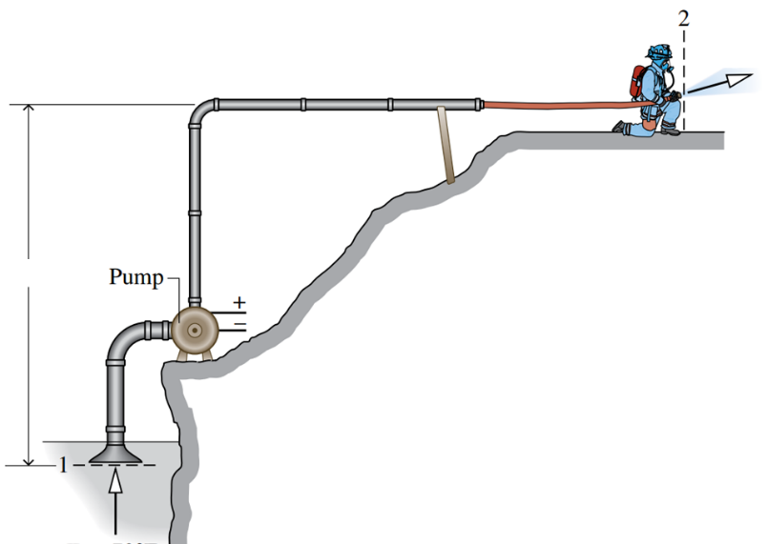
- Question 1(30 Points)
A pump steadily draws water from a pond at a volumetric flow rate of 0.015[${m^{3}}/s$] through a pipe having a 0.25[m] diameter inlet. The water is delivered through a hose terminated by a converging nozzle. The nozzle exit has a diameter of 0.025[m] and is located 10[m] above the pipe inlet. Water enters at 20°C, 1 [bar] and exits with no change in temperature or pressure. The rate of heat transfer is 5% of the power input.
Use Eq 2, 3
- Determine specific volume from Table A-2
- Determine mass flow rate
- Determine the velocity of the water at the inlet and exit, each in m/s,
- Determine change in enthalpy [Note: No change in pressure/temperature]
- Determine the power required by the pump, in kW

- From Table A-2, $v=0.0010018$
- $\dot{m}=\frac{A_{1}V_{1}}{v_{1}}=\frac{0.015}{0.0010018}=14.97\left[\frac{kg}{s}\right]$
- $V_{1}=\frac{\dot{m}v}{A_{1}}=\frac{14.97*0.0010018}{π*\frac{{0.25}^{2}}{4}}=0.3055\left[\frac{m}{s}\right]$
- $V_{2}=\frac{\dot{m}v}{A_{2}}=\frac{14.97*0.0010018}{π*\frac{{0.025}^{2}}{4}}=30.55\left[\frac{m}{s}\right]$
- $h_{1}-h_{2}=0$
- $Q=0.05W→{\dot{W}}_{cv}=$ $\frac{\dot{m}}{0.95}\left(\left(h_{1}-h_{2}\right)+\frac{\left(\frac{V_{1}^{2}-V_{2}^{2}}{2}\right)+g\left(ΔZ\right)}{1000}\right)$
${\dot{W}}_{cv}=$ $\frac{14.97}{0.95}\left(0+\frac{\left(\frac{{0.3055}^{2}-{30.55}^{2}}{2}\right)+9.8\left(-10\right)}{1000}\right)=-8.89 kW$

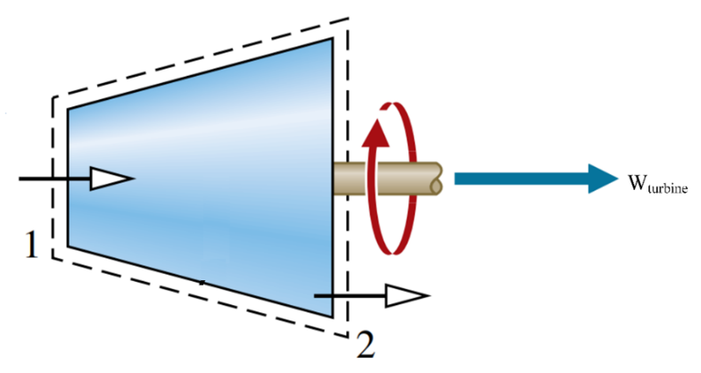
- Question 2(30 Points)
Steam flows steadily through an adiabatic turbine. The inlet conditions of the steam are 4 MPa pressure, 500 ˚C temperature, and 80 m/s velocity and the exit conditions are 50 kPa, 90% quality, and 50 m/s. The mass flow rate of the steam is 12 kg/s.
Use Eq 1, 2, 4, 5
Determine:
- Change in Kinetic Energy
- Enthalpy at inlet & exit from Table A-4 & A-3
- Power Output
- Determine specific volume at inlet from Table A-4
- Turbine inlet area

$$KE=\dot{m}\frac{\left(V_{1}^{2}-V_{2}^{2}\right)}{2}=12*\frac{{80}^{2}-{50}^{2}}{2}=23400 J=23.4 kJ$$
- $h_{1}=3445.3 \left[\frac{kJ}{kg}\right]$
- $h_{f}=340.49;h_{g}=2645.9;h_{2}=340.49+0.90\left(2645.9-340.49\right)=2415.359\left[\frac{kJ}{kg}\right]$
- $\dot{W}=\dot{m}\left(h_{1}-h_{2}+\frac{V_{1}^{2}-V_{2}^{2}}{2}\left(\frac{1}{1000}\right)\right)$
- $\dot{W}=12\left(3445.3-2415.359\right)+23.4=12382.7 kW$
- $v=0.08643\frac{m^{3}}{kg}$
$$v=\frac{A*V}{\dot{m}}→A=\frac{\dot{m}*v}{V}=\frac{12*0.08643}{80}=0.0129645m^{2}$$

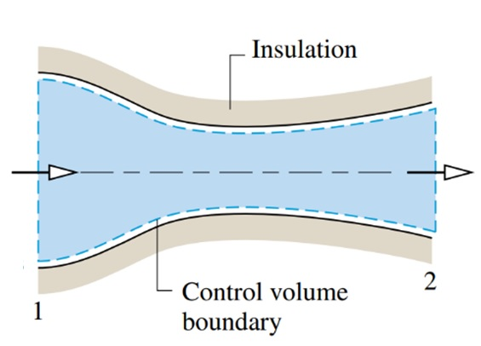
- Question 4(20 Points)
Steam enters a converging–diverging nozzle operating at steady state with p₁ = 140 [bar], T₁ = 400°C, and a velocity of 10 [m/s]. The steam flows through the nozzle with no change in PE, Q, W. At the exit, p₂ = 40 [bar], and the velocity is 700 [m/s]. The mass flow rate is 2 [kg/s].
Use Eq 1, 2
- Determine h₁ from Table A-4
- Determine h₂
- Determine v₂ from Table A-4
- Determine the exit area of the nozzle, in [$m^{2}]$.

From Table A-4, $h_{1}=3001.9\left[\frac{kJ}{kg}\right]$
$$0=\left(h_{1}-h_{2}\right)+\left(\frac{V_{1}^{2}-V_{2}^{2}}{2}\right)→$$
$$h_{2}=3001.9\left[\frac{kJ}{kg}\right]+\frac{{10}^{2}-{700}^{2}}{2}\left[\frac{m^{2}}{s^{2}}\right]*\left[\frac{1N}{1kg⋅\frac{m}{s^{2}}}\right]*\left[\frac{1kJ}{{10}^{3}N⋅m}\right]=2756.95\left[\frac{kJ}{kg}\right]$$
From Table A-4, $v_{2} =0.07341\left[\frac{m^{3}}{kg}\right]$
$$A_{2}=\frac{\dot{m}v_{2}}{V_{2}}→A_{2}=\frac{2*0.07341}{700}=20.9{cm}^{2}$$

- ${\dot{Q}}_{cv}+{\dot{W}}_{cv}=\dot{m}\left(\left(h_{1}-h_{2}\right)+\left(\left(\frac{V_{1}^{2}-V_{2}^{2}}{2}\right)+g\left(z_{1}-z_{2}\right)\right)\frac{1}{1000}\right)$[1000 is needed in metric.]
- $\dot{m}=\frac{AV}{v}→V=\frac{\dot{m}v}{A}→A=\frac{\dot{m}v}{V}$
- $\dot{Q}+\dot{W}=∑{\dot{m}}_{i}\left(h_{i}+\frac{V_{i}^{2}}{2}+gz_{i}\right)-∑{\dot{m}}_{e}\left(h_{e}+\frac{V_{e}^{2}}{2}+gz_{e}\right)$
- $KE=\dot{m}\frac{\left(V_{1}^{2}-V_{2}^{2}\right)}{2}$
- $h=h_{f}+x\left(h_{g}-h_{f}\right)$

